1. OLD TEMPLATE OF PDF RESPONSE (total number of pages for the response: 2)

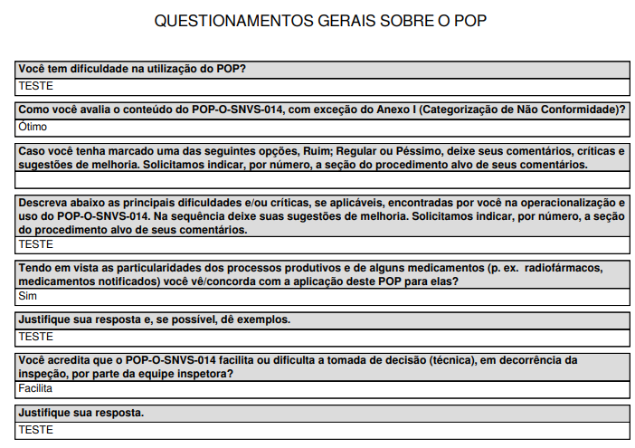

2. NEW TEMPLATE OF PDF RESPONSE (total number of pages for the response: 9)

